**Osternester**

[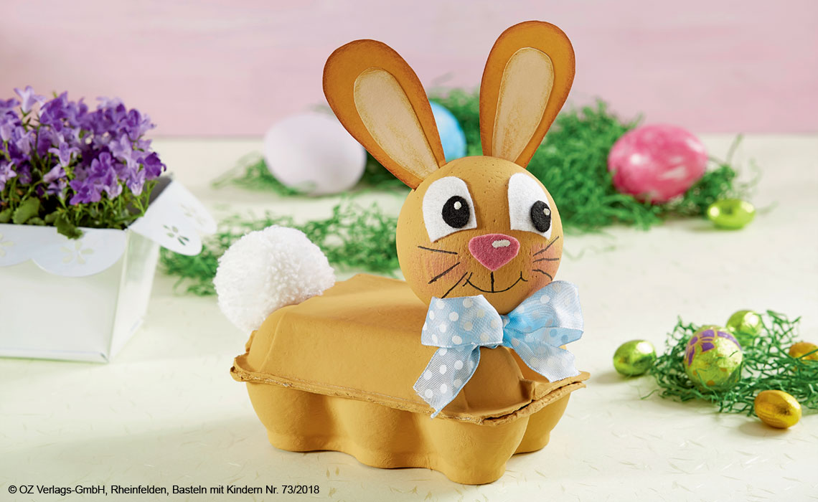](https://www.google.de/url?sa=i&rct=j&q=&esrc=s&source=imgres&cd=&cad=rja&uact=8&ved=2ahUKEwirvLWM4rLoAhVBsaQKHTU6DGQQjRx6BAgBEAQ&url=https://www.oz-verlag.de/tierischer-oster-bastelspass/&psig=AOvVaw1x9flP6RnbYvl45m0kdhhW&ust=1585127463039983)

[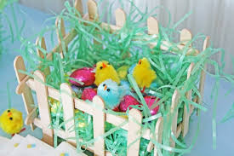](https://www.google.de/url?sa=i&rct=j&q=&esrc=s&source=imgres&cd=&cad=rja&uact=8&ved=2ahUKEwjcgrzW4bLoAhWKyKQKHeT_B_sQjRx6BAgBEAQ&url=https://deavita.com/dekoration/ostern-frueling/osterkoerbchen-basteln-mit-kindern-ideen-diy.html&psig=AOvVaw34Qk27XdT47tH-r991Enx5&ust=1585127349866729)