[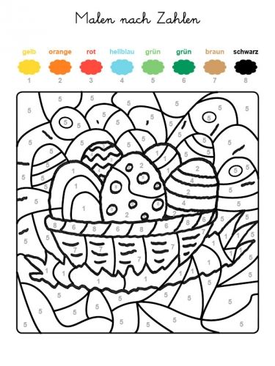](https://www.google.de/url?sa=i&url=https://www.pinterest.com/pin/376332112597662343/&psig=AOvVaw0sIxCC4k6p2aKLh87XGPN_&ust=1585127182803000&source=images&cd=vfe&ved=0CAIQjRxqFwoTCLjR1uHnsugCFQAAAAAdAAAAABAE)